TEAM COLLABORATION PORTAL
@CREATIVITY THINK (9483175986/7019689991)

ABSTRACT:
Team Collaboration Portal is a web application designed to streamline group and project management for teams, startups, and remote work environments. Users can join or create teams, share files, manage project boards, chat in real-time, and track progress through dashboards. Administrators oversee team and project creation, moderate files, configure integrations, and monitor dashboard analytics. Built with Django and Django Rest Framework for backend services and React, Redux, and socket.io for frontend and real-time communication, this system enhances team productivity, ensures efficient collaboration, and centralizes project tracking for effective organizational management..

INTRODUCTION OF THE PROJECT:
Effective collaboration is vital for team productivity, especially in remote and hybrid work setups. Team Collaboration Portal provides a platform where team members can create or join teams, share files, manage project boards, engage in real-time chat, and monitor progress via dashboards. Administrators can configure teams, moderate content, integrate external tools, and review analytics. The backend, powered by Django and Django Rest Framework, handles authentication, project management, and API requests, while React and socket.io provide dynamic interfaces and live chat. This system centralizes team communication and project tracking for improved efficiency and accountability..

PROJECT OBJECTIVES:

• Enable seamless creation and management of teams and projects
• Provide file sharing and project collaboration features
• Integrate real-time chat for instant team communication
• Display progress and performance through dashboards
• Allow administrators to manage teams, moderate files, and configure integrations
• Ensure secure data handling and role-based access control
• Facilitate analytics for project and team performance evaluation

PROBLEM OF THE STATEMENT:
Team collaboration in modern workplaces often faces challenges such as scattered communication, inefficient file sharing, lack of project visibility, and difficulty in tracking progress. Without a centralized system, teams struggle to coordinate tasks and maintain accountability. Team Collaboration Portal addresses these challenges by providing a unified web platform where team members and administrators can efficiently communicate, manage projects, share files, and monitor performance through dashboards. It reduces miscommunication, enhances productivity, and enables managers to make data-driven decisions..

MOTIVATION OF THE PROJECT:
• Improve collaboration among distributed teams and remote workers
• Centralize project management and task tracking
• Facilitate secure and efficient file sharing
• Provide real-time communication through chat
• Offer analytics for monitoring team performance

BLOCK DAIGRAM OF PROJECT:

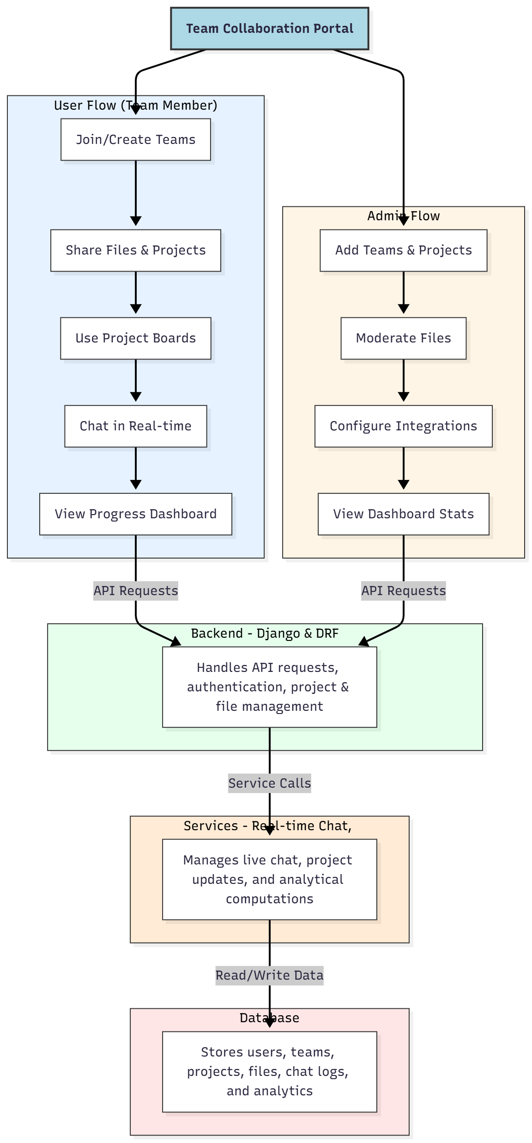

WORKING OF THE PROJECT:
Users join or create teams, share files, manage project boards, communicate via real-time chat, and monitor progress using dashboards. Administrators add teams and projects, moderate files, configure external integrations, and review dashboard analytics. The backend handles API requests, authentication, project and file management, while services manage live chat and analytical computations. The database stores users, teams, projects, files, chat logs, and analytics. This system enables seamless collaboration, reduces miscommunication, and centralizes project tracking for efficient team operations..

SOFTWARE REQUIREMENT:
- Backend:
  - Python 3.x
  - Django
  - Django REST Framework
  - SQLite/PostgreSQL
- Frontend:
  - Node.js and npm
  - React.js
  - Axios
- Development Tools:
  - Visual Studio Code
  - Postman (for testing APIs)
  - Git/GitHub (for version control)
- Server/Deployment (Optional):
  - Gunicorn, Nginx, or Heroku/AWS for hosting

ADVANTAGES OF THE PROJECT:

• Centralizes team collaboration and project management
• Provides real-time chat for instant communication
• Offers file sharing and project board management
• Ensures role-based access and administrative control
• Visualizes progress with dashboards and analytics
• Reduces miscommunication and task delays
• Supports remote work and distributed teams
• Enhances productivity and accountability

APPLICATIONS OF THE PROJECT:
• Startups and corporate teams for project collaboration
• Remote work teams for communication and task management
• Small businesses for workflow organization
• Educational institutions for team projects
• Real-time file sharing and collaboration
• Project tracking with analytics dashboards
• Integration with external tools for enhanced productivity
• Monitoring and reporting team performance

REFERENCES:

- Django REST Framework Documentation — Django Software Foundation. Django Documentation. Available: https://docs.djangoproject.com/
- Django REST Framework. DRF Documentation. Available: https://www.django-rest-framework.org/
- React. React Official Documentation. Available: https://reactjs.org/docs/getting-started.html
- Redux. Redux Documentation. Available: https://redux.js.org/introduction/getting-started
- PostgreSQL Global Development Group. PostgreSQL Documentation. Available: https://www.postgresql.org/docs/
- MySQL. MySQL Reference Manual. Available: https://dev.mysql.com/doc/
- Git. Git Documentation. Available: https://git-scm.com/doc
- Node.js. Node.js Documentation. Available: https://nodejs.org/en/docs/
- Axios. Axios Documentation. Available: https://axios-http.com/docs/intro
- Socket.io Documentation – https://socket.io/docs/

